CHARITY DONATION

UI/UX Design Fundamentals - Christ University

**Submitted By:**

**Team Members:-**

**Full Name & Roll Number:**

Devika T.R & 2462064

Ashitha Vinod K & 2462048

Florentina Francis & 2462070

**College Email id:**

[devika.tr@btech.christuniversity.in](mailto:devika.tr@btech.christuniversity.in)

[ashitha.vinod@btech.christuniversity.in](mailto:ashitha.vinod@btech.christuniversity.in)

[florentina.francis@btech.christuniversity.in](mailto:florentina.francis@btech.christuniversity.in)

**Instructor Name:**

Ms. Nagaveena

**Index:**

* **Abstract**
* **Objectives**
* **Scope of the Project**
* **Tools & Technologies Used**
* **HTML Structure Overview**
* **CSS Styling Strategy**
* **Key Features**
* **Challenges Faced & Solutions**
* **Outcome**
* **Future Enhancements**
* **Sample Code**
* **Screenshots of Final Output**
* **Conclusion**
* **References**

**1. Abstract:**

The Charity Donation Landing Page is a responsive, visually appealing, and user-friendly web interface designed to encourage and facilitate charitable contributions. Built using HTML and CSS, the page provides a clear structure for presenting the organization’s mission, impact statistics, donation tiers, testimonials, and a contact form for engagement. The design focuses on simplicity and accessibility, ensuring visitors can quickly understand the cause and take action. By integrating visually distinct sections such as a hero banner, about segment, impact metrics, and call-to-action areas, the project aims to inspire trust, promote transparency, and drive meaningful donations that contribute to positive social change.

**2.Objectives:**

1. Promote the Charity’s Mission – Clearly communicate the purpose, values, and goals of the organization to build trust and inspire support.
2. Encourage Donations – Provide multiple donation options with clear descriptions to motivate visitors to contribute.
3. Showcase Impact – Present key statistics and achievements to demonstrate the tangible results of donor contributions.
4. Build Credibility – Include testimonials and transparent information to assure visitors of the organization’s authenticity.
5. Enhance User Engagement – Offer a simple, responsive design with intuitive navigation for an improved user experience across devices.
6. Facilitate Communication – Include a contact form to enable donors and supporters to easily reach out to the organization.
7. Raise Awareness – Spread information about ongoing initiatives to encourage community participation beyond monetary donations

**3. Scope of the Project:**

The Charity Donation Landing Page project focuses on designing and developing a static, responsive web interface that serves as a central hub for a charity organization’s online presence. The scope includes:

* Front-End Development: Implementing the structure using HTML and styling it with CSS to ensure visual appeal and ease of navigation.
* Responsive Design: Ensuring compatibility across desktops, tablets, and mobile devices for a seamless user experience.
* Content Presentation: Displaying the organization’s mission, impact statistics, donation tiers, and supporter testimonials in a clear and engaging format.
* Donation Promotion: Providing visually distinct sections to highlight various contribution options and their direct benefits.
* User Interaction: Incorporating a functional contact form to encourage communication between the organization and potential donors or volunteers.
* Non-Transactional Focus: This project does not integrate back-end payment gateways or databases; it is intended as a front-end design concept that can be extended with server-side functionalities in the future.

**4. Tools & Technologies Used:**

1. HTML5 – For structuring the web page content, including headings, paragraphs, images, navigation menus, and forms.
2. CSS3 – For styling the layout, colors, typography, and responsive design elements.
3. Google Fonts (Poppins) – To enhance text readability and create a modern, professional appearance.
4. Responsive Web Design Techniques – Utilizing CSS Flexbox and media queries to ensure the page adapts to various screen sizes.
5. Text Editor / IDE – Such as Visual Studio Code for writing and managing the HTML and CSS code.
6. Web Browser – For testing and previewing the landing page during development (e.g., Google Chrome, Mozilla Firefox).
7. Image Assets – A charity-related image (donation.jpg) to visually reinforce the cause and make the design more engaging.

**5. HTML Structure Overview:**

**The HTML structure of the Charity Donation Landing Page is organized into semantic sections for clarity, maintainability, and accessibility:**

1. <head> Section
   * Declares the document type and language.
   * Includes meta tags for character encoding (**UTF-8) and viewport settings for responsiveness.**
   * **Links the external CSS file (charity.css) and Google Fonts (Poppins).**
   * **Defines the page title.**
2. **Header (**<header>)
   * Contains the organization’s tagline (“Giving hope, changing lives”).
   * Includes a navigation menu with anchor links to key sections: About, Impact, Donate, and Contact.
3. Hero Section (<section class="hero">)
   * Features a main heading and introductory paragraphs outlining the mission.
   * Includes a prominent “Donate Now” button linking to the donation section.
4. About Section (<section id="about">)
   * Provides a brief description of the organization’s purpose and activities.
5. Impact Section (<section id="impact">)
   * Displays impact-related statistics using a flexbox layout.
   * Each statistic includes a number and a descriptive text (e.g., meals served, children supported).
6. Donation Tiers Section (<section id="donate">)
   * Presents three predefined donation amounts with descriptions and “Donate” buttons.
7. Testimonials Section (<section class="testimonials">)
   * Displays supporter feedback in styled testimonial cards.
8. Contact Section (<section id="contact" class="cta">)
   * Contains a simple contact form with fields for name, email, and message, along with a “Send Message” button.
9. Footer (<footer>)
   * Shows copyright information.
   * Provides links to the organization’s social media platforms.

**6. CSS Styling Strategy:**

**The Charity Donation Landing Page uses a clean, warm, and responsive CSS styling approach to create an inviting and user-friendly interface. The main strategies applied include:**

1. **Global Reset and Base Styling**
   * **Applied margin: 0; padding: 0; box-sizing: border-box; to reset default browser styles.**
   * **Set a consistent font (Poppins, sans-serif) and a soft background color (#fff8f3) for a welcoming feel.**
2. **Color Scheme**
   * **Warm and compassionate tones such as #e85a4f (primary), #e98074 (secondary), and soft neutrals for text.**
   * **Contrasting colors for buttons and headings to draw user attention to important elements.**
3. **Typography**
   * **Headings use bold weights (font-weight: 600) for emphasis.**
   * **Paragraphs maintain a comfortable line-height: 1.6 for readability.**
4. **Layout and Alignment**
   * **Flexbox is used for key sections (stats, donation tiers, testimonials) to evenly distribute items and maintain alignment.**
   * **Responsive media queries adjust layouts to stack vertically on smaller screens.**
5. **Navigation Styling**
   * **Simple, white text links with hover underline effects for clarity and interactivity.**
6. **Call-to-Action (CTA) Buttons**
   * **Buttons are styled with bold background colors, rounded corners, and hover effects for visual feedback.**
7. **Cards and Boxes**
   * **Donation tiers and testimonial boxes feature white backgrounds, padding, rounded edges, and subtle shadows for a modern card-like effect.**
8. **Responsive Design**
   * **At max-width: 768px, sections stack vertically to ensure mobile usability.**
   * **Fonts, padding, and spacing adjust automatically for smaller viewports.**

**7. Key Features:**

1. Responsive Design – The layout automatically adapts to different screen sizes, ensuring a smooth user experience on desktops, tablets, and mobile devices.
2. Clear Navigation Menu – A fixed header with direct anchor links allows users to quickly jump to different sections of the page.
3. Engaging Hero Section – Prominent headline, mission statement, and a “Donate Now” call-to-action button encourage immediate visitor engagement.
4. Impact Statistics – Visually appealing stat boxes display key achievements such as meals served, children supported, and medical check-ups provided.
5. Donation Tiers – Predefined donation amounts with descriptions and easy-to-click buttons simplify the donation decision process.
6. Supporter Testimonials – Positive feedback from donors adds credibility and trustworthiness to the organization.
7. Contact Form – A simple form allows visitors to easily reach out for inquiries, volunteering, or collaboration opportunities.
8. Social Media Integration – Footer links connect users to the organization’s social platforms for extended engagement.
9. Consistent Branding – Warm, compassionate color palette and professional typography maintain a unified and trustworthy brand image.

**8. Challenges Faced & Solutions:**

1. Ensuring Mobile Responsiveness
   * *Challenge:* Initial layouts appeared cluttered and misaligned on smaller devices.
   * *Solution:* Implemented CSS Flexbox with flex-direction: column in media queries for screen widths below 768px, ensuring elements stack neatly.
2. Balancing Visual Appeal with Simplicity
   * *Challenge:* Overuse of colors and effects initially made the design distracting.
   * *Solution:* Adopted a limited warm-toned color palette and consistent typography, reducing visual noise while maintaining attractiveness.
3. Creating Readable and Accessible Text
   * *Challenge:* Some text blended into background colors, reducing readability.
   * *Solution:* Adjusted contrast between text and background, used larger font sizes for headings, and ensured adequate line spacing

**9. Outcome:**

The Charity Donation Landing Page successfully delivers a visually appealing, responsive, and user-friendly platform for promoting a charity organization’s mission and encouraging donations. The project meets its primary objectives by:

* Clearly communicating the organization’s purpose through concise content and impactful visuals.
* Showcasing measurable achievements via well-presented statistics to build credibility.
* Offering predefined donation tiers to simplify the decision-making process for donors.
* Providing a seamless browsing experience across desktop, tablet, and mobile devices.
* Facilitating user engagement through a contact form and social media links.

While the page currently functions as a static front-end interface, it has been designed with scalability in mind, making it easy to integrate back-end functionality such as secure payment gateways, donor databases, and live campaign tracking in the future.

**10. Future Enhancements:**

1. Payment Gateway Integration – Add secure online payment options to enable direct donations through the website.
2. Donor Management System – Implement a backend database to store donor details, track contributions, and send automated thank-you messages.
3. Real-Time Impact Tracker – Display live statistics on donations received and beneficiaries supported.
4. Multi-Language Support – Offer content in multiple languages to reach a broader audience.
5. Volunteer Registration Module – Include an online form for people to sign up as volunteers for upcoming events.

**11.Sample Code:**

**This is sample html for the code:-**

<!-- HERO SECTION -->

<section class="hero">

<h1>Together, We Can Make a Difference</h1>

<p>Your donation helps us bring hope, food, and education to those in need.</p>

<a href="#donate" class="btn">Donate Now</a>

</section>

<!-- DONATION TIERS -->

<section id="donate" class="donation">

<h2>Choose a Donation Amount</h2>

<div class="tiers">

<div class="tier">

<h3>₹500</h3>

<p>Provide food for a family for a week.</p>

<button>Donate ₹500</button>

</div>

<div class="tier">

<h3>₹1000</h3>

<p>Support a child's education for a month.</p>

<button>Donate ₹1000</button>

</div>

<div class="tier">

<h3>₹5000</h3>

<p>Fund a community healthcare camp.</p>

<button>Donate ₹5000</button>

</div>

</div>

</section>

**This is sample css for the code:-**

.tiers {

display: flex;

justify-content: center;

gap: 1.5rem;

margin-top: 1.5rem;

}

.tier {

background: white;

padding: 1rem;

border-radius: 8px;

box-shadow: 0 4px 6px rgba(0,0,0,0.1);

width: 200px;

}

.tier button {

margin-top: 1rem;

background: #e85a4f;

color: white;

border: none;

padding: 0.5rem 1rem;

cursor: pointer;

border-radius: 5px;

}

.tier button:hover { background: #d6453d; }

/* RESPONSIVE */

@media (max-width: 768px) {

.tiers {

flex-direction: column;

align-items: center;

}

}

**12.Screenshots of Final Output**

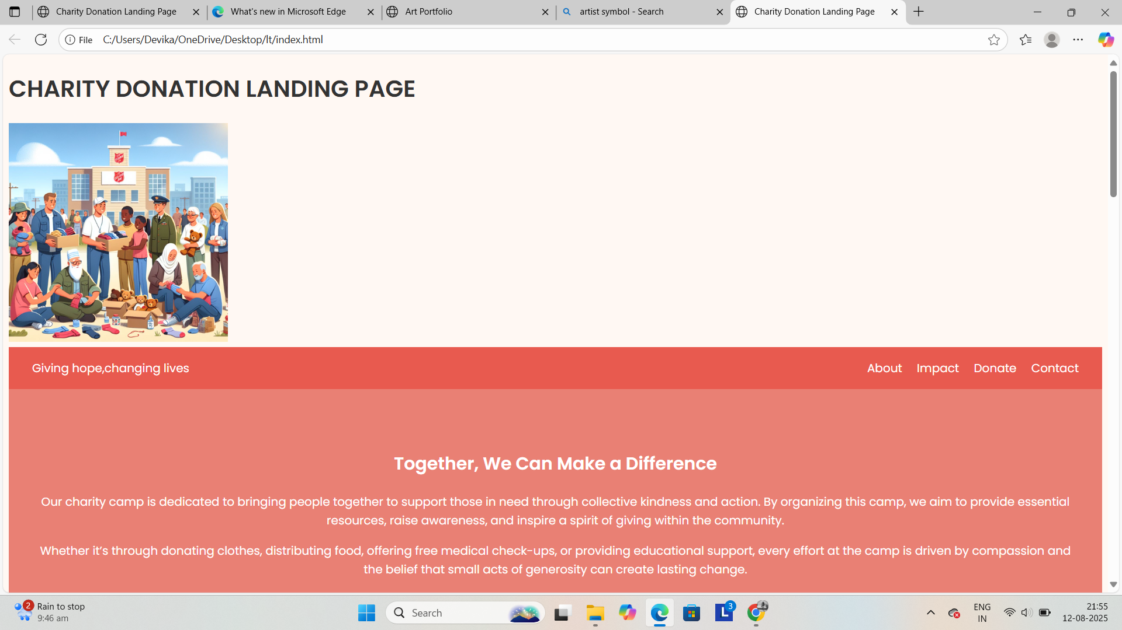

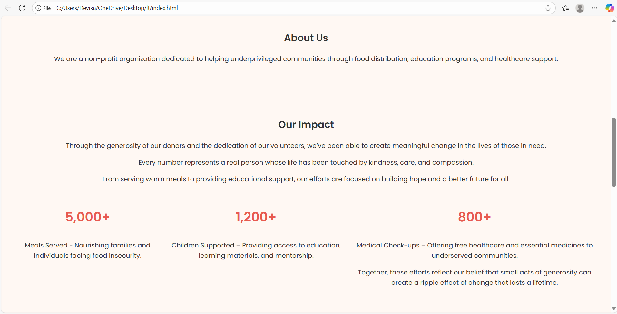

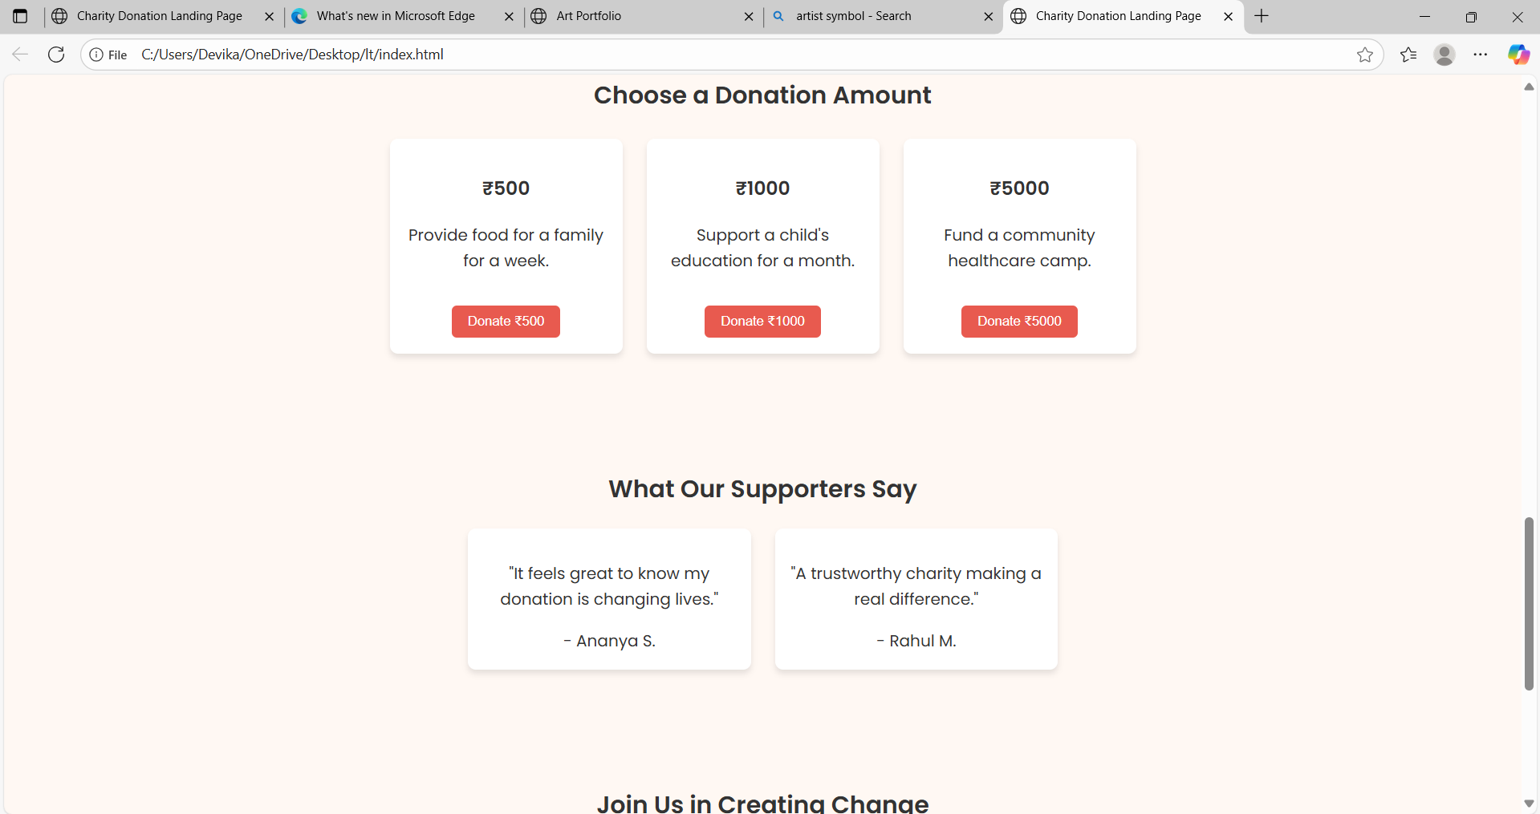

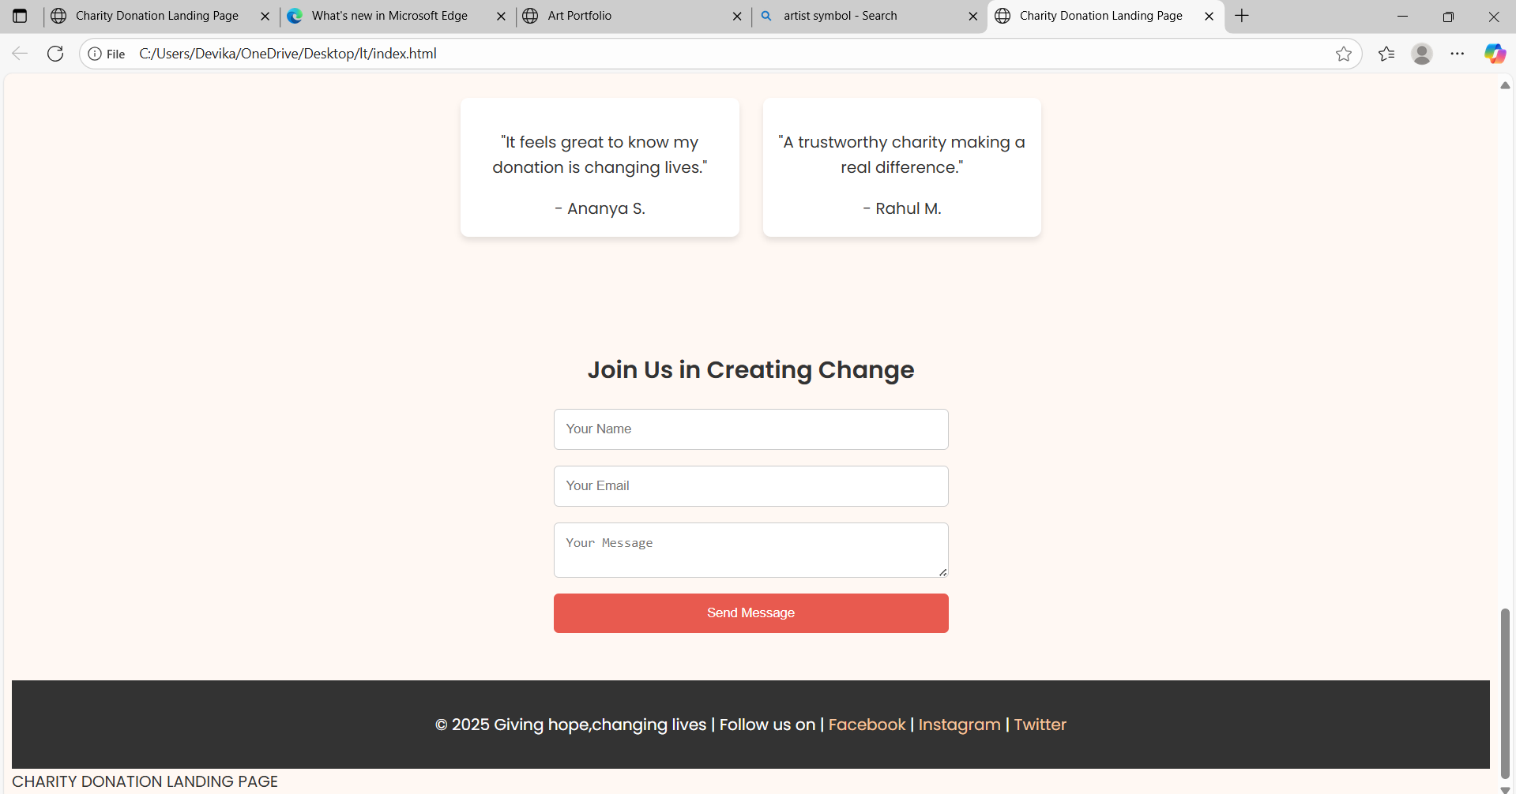

**13. Conclusion:**

The Charity Donation Landing Page successfully demonstrates how a well-structured and visually appealing front-end design can effectively convey an organization’s mission, engage visitors, and encourage contributions. Through a combination of clean HTML structure, warm and consistent CSS styling, and responsive layout techniques, the page ensures accessibility and usability across devices.

While the current implementation focuses on static content, it provides a strong foundation for future enhancements such as online payment integration, donor management systems, and real-time campaign tracking. The project not only fulfills its primary objectives but also serves as a scalable model for other non-profit organizations seeking to establish a credible and impactful online presence

**14. References:**

**W3Schools – HTML & CSS Tutorials**

**CSS-Tricks – Flexbox & Grid Guide**

**Placeholder.com – Free Placeholder Images**